Overview

Administrator and Developer Function for each user

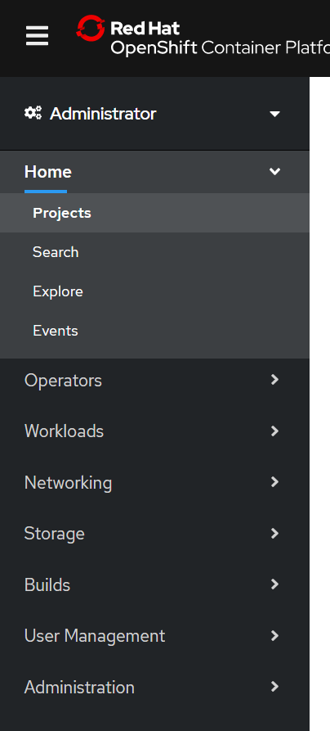

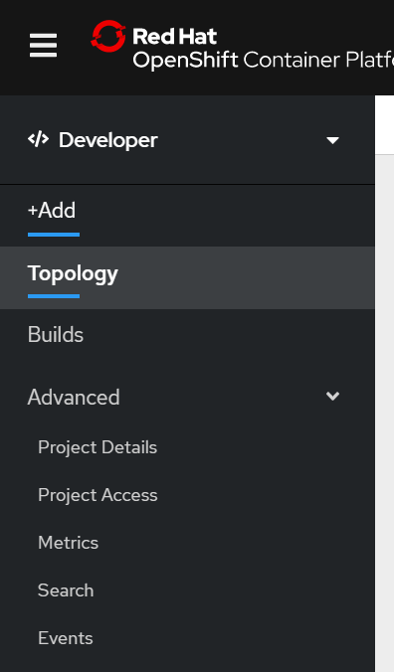

User os4user access to only some project

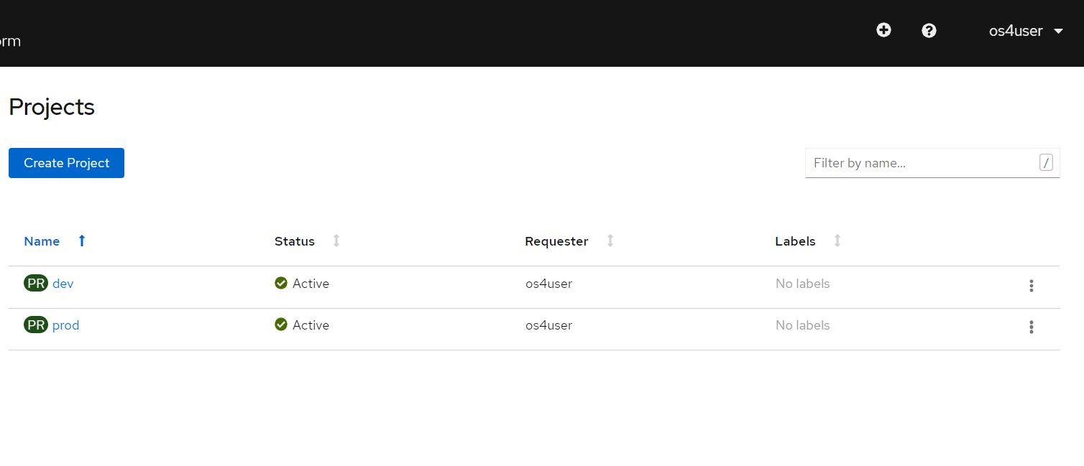

os4admin has access to all projects

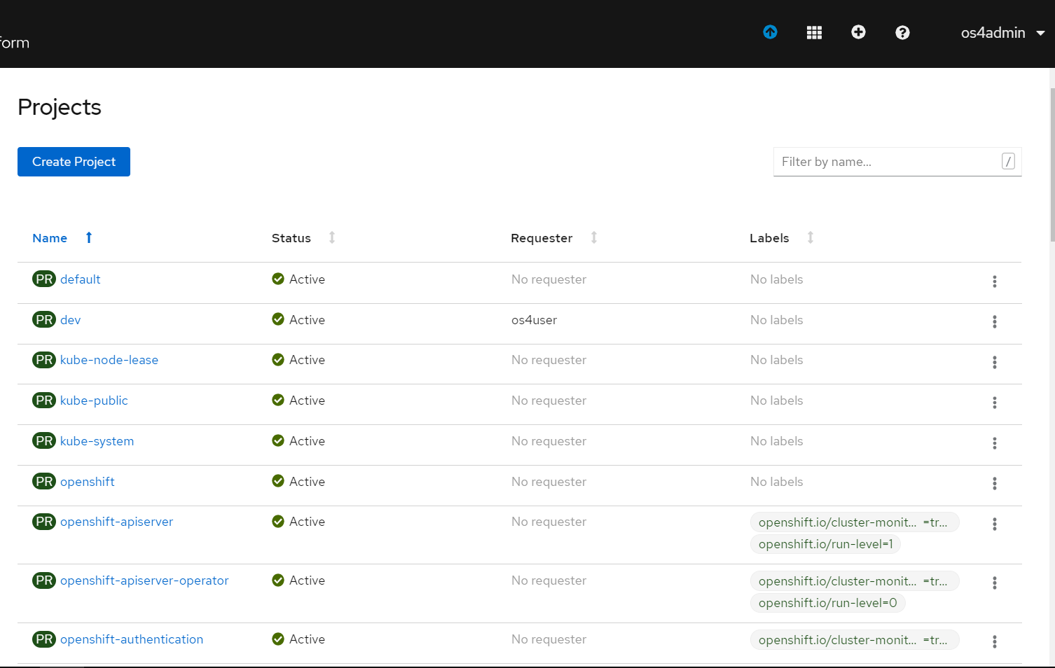

Catalog

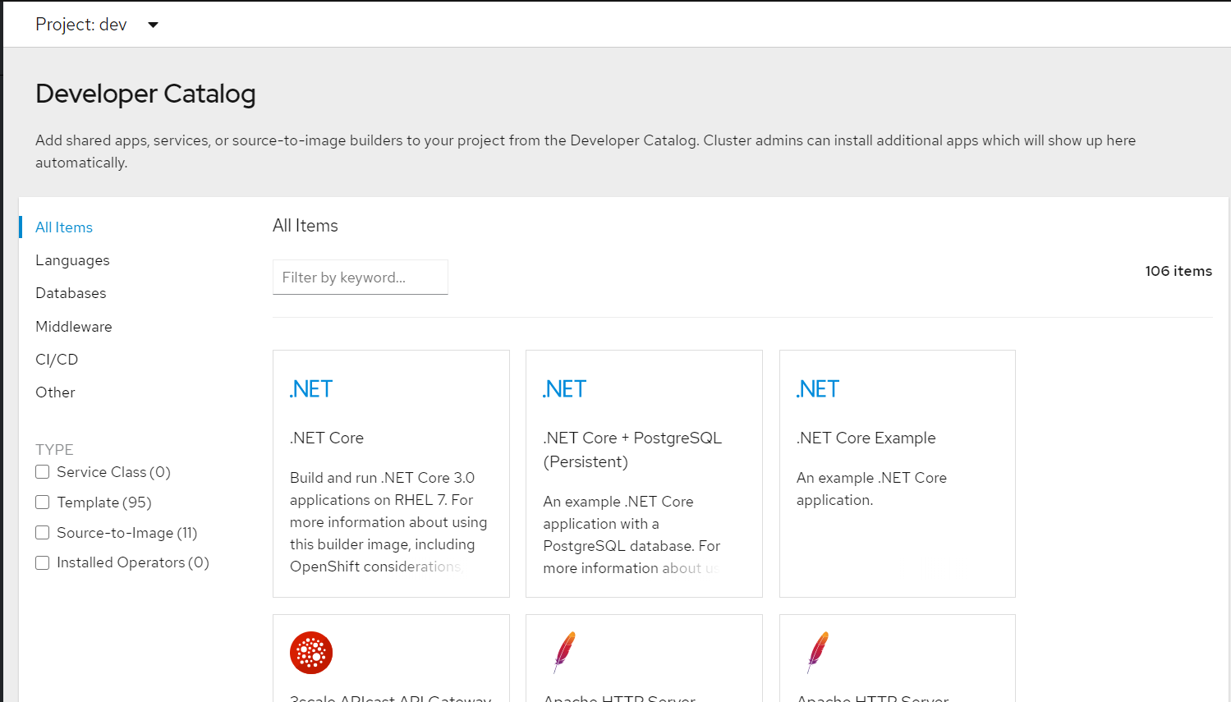

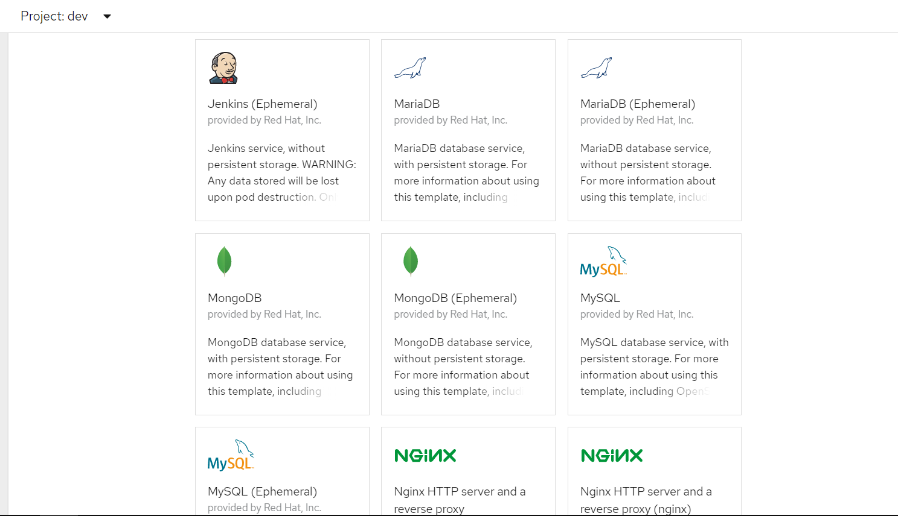

Configuration

Openshift

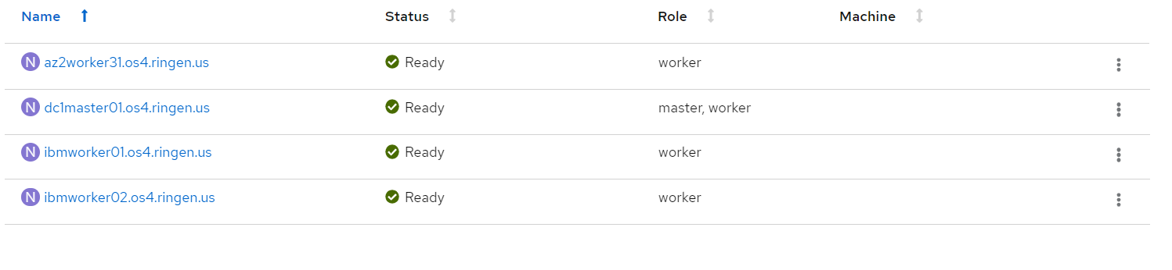

DC1

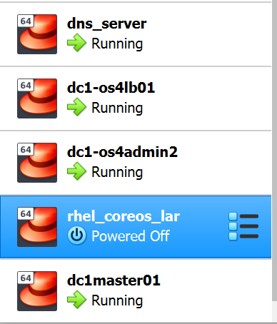

IBM

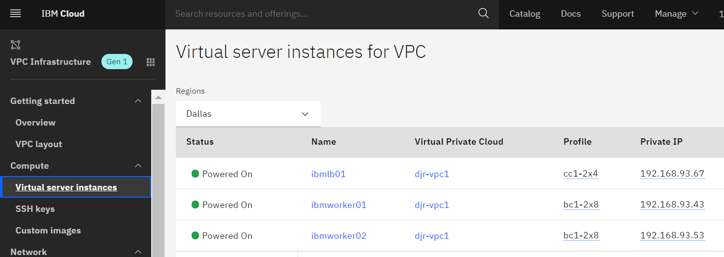

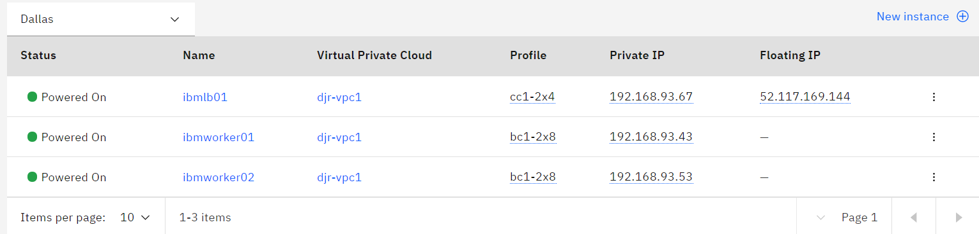

Azure

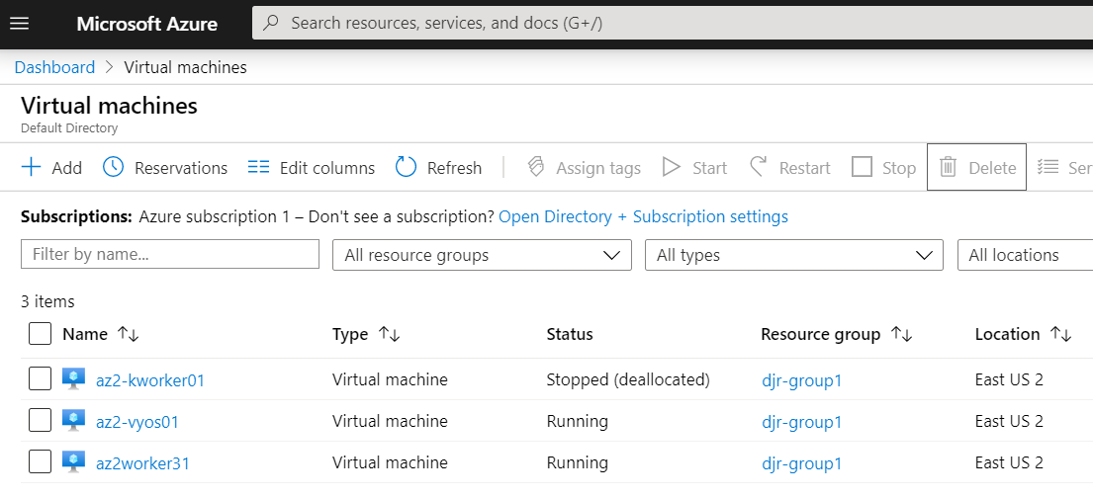

Demo

Production (prod) Project

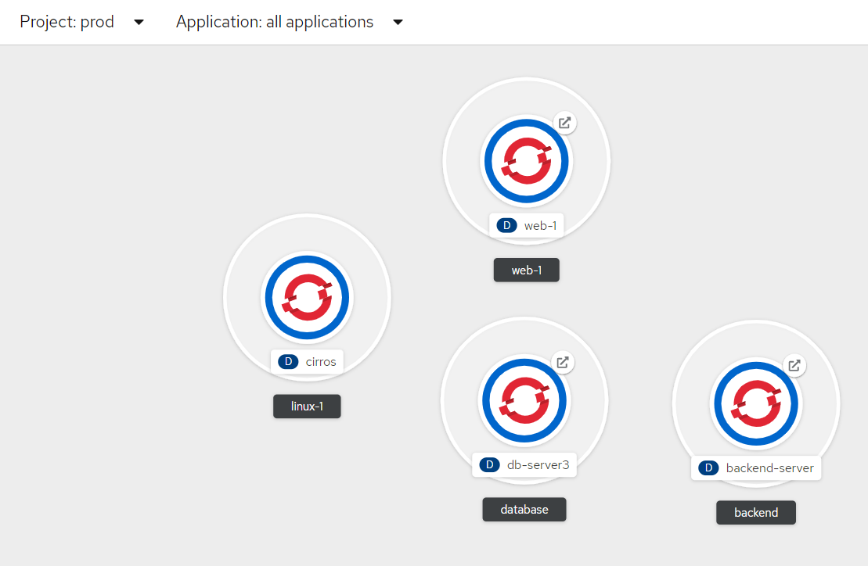

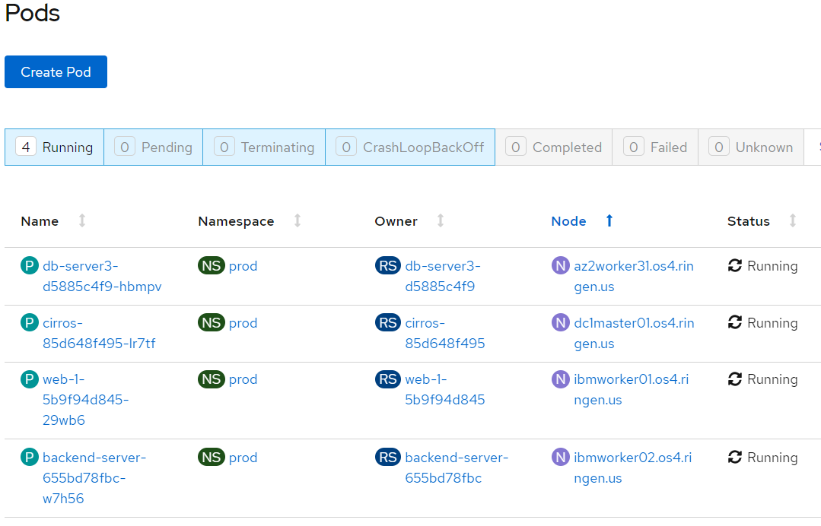

**Default Behavior is that any pod (application) and can communicate and any other pod in the same project.**

[djr@dc1os4admin ~]$ oc get services -n prod

NAME TYPE CLUSTER-IP EXTERNAL-IP PORT(S) AGE

backend-server ClusterIP 172.30.106.128 <none> 8080/TCP,8443/TCP 75m

cirros ClusterIP 172.30.173.2 <none> 8080/TCP 4h

db-server3 ClusterIP 172.30.138.126 <none> 8080/TCP,8443/TCP 99m

web-1 ClusterIP 172.30.119.47 <none> 8080/TCP,8443/TCP 4h4m

**Database Service**

Annotations: openshift.io/generated-by: OpenShiftWebConsole

Selector: app=db-server3,deploymentconfig=db-server3

Type: ClusterIP

IP: 172.30.138.126

Port: 8080-tcp 8080/TCP

TargetPort: 8080/TCP

Endpoints: 10.241.3.4:8080

Port: 8443-tcp 8443/TCP

TargetPort: 8443/TCP

Endpoints: 10.241.3.4:8443

Session Affinity: None

Events: <none>

**Allow any-to-any example**

[djr@dc1os4admin ~]$ oc exec -it web-1-5b9f94d845-t9zw4 bash -n prod

1000540000@web-1-5b9f94d845-t9zw4:/app$ curl -i backend-server:8080

HTTP/1.1 200 OK

Date: Thu, 14 May 2020 19:05:07 GMT

Server: Apache/2.4.43 (Unix) OpenSSL/1.1.1d

Last-Modified: Sat, 09 May 2020 21:38:37 GMT

ETag: "3c-5a53defb8b140"

Accept-Ranges: bytes

Content-Length: 60

Content-Type: text/html

<html>

<body>

<h1><br>BACKEND service</h1>

</body>

</html>

1000540000@web-1-5b9f94d845-t9zw4:/app$ curl -i db-server3:8080

HTTP/1.1 200 OK

Date: Thu, 14 May 2020 19:05:27 GMT

Server: Apache/2.4.43 (Unix) OpenSSL/1.1.1d

Last-Modified: Sat, 09 May 2020 21:23:24 GMT

ETag: "3d-5a53db94d6b00"

Accept-Ranges: bytes

Content-Length: 61

Content-Type: text/html

<html>

<body>

<h1><br>DATABASE service</h1>

</body>

</html>

**Network Policy to deny all traffic**

apiVersion: networking.k8s.io/v1

kind: NetworkPolicy

metadata:

name: default-deny-ingress

namespace: prod

spec:

podSelector: {}

policyTypes:

- Ingress

**Connectivity is now denied**

NAME TYPE CLUSTER-IP EXTERNAL-IP PORT(S) AGE

backend-server ClusterIP 172.30.106.128 <none> 8080/TCP,8443/TCP 107m

cirros ClusterIP 172.30.173.2 <none> 8080/TCP 4h32m

db-server3 ClusterIP 172.30.138.126 <none> 8080/TCP,8443/TCP 131m

web-1 ClusterIP 172.30.119.47 <none> 8080/TCP,8443/TCP 4h35m

**web to backend and database is not blocked**

1000540000@web-1-5b9f94d845-t9zw4:/app$

[djr@dc1os4admin ~]$ oc exec -it web-1-5b9f94d845-t9zw4 bash -n prod

1000540000@web-1-5b9f94d845-t9zw4:/app$ curl -i backend-server:8080

[djr@dc1os4admin ~]$ oc exec -it web-1-5b9f94d845-t9zw4 bash -n prod

1000540000@web-1-5b9f94d845-t9zw4:/app$ curl -i db-server3:8080

[djr@dc1os4admin ~]$

[djr@dc1os4admin ~]$ oc exec -it backend-server-dbf9c64df-vp7j5 bash -n prod

1000540000@backend-server-dbf9c64df-vp7j5:/app$ curl -i web-1:8080

[djr@dc1os4admin ~]$ oc exec -it backend-server-dbf9c64df-vp7j5 bash -n prod

1000540000@backend-server-dbf9c64df-vp7j5:/app$ curl -i db-server3:8080

**Create network polices to allow traffic**

kind: NetworkPolicy

apiVersion: networking.k8s.io/v1

metadata:

name: web-ingress

namespace: prod

spec:

podSelector:

matchLabels:

app: web-1

policyTypes:

- Ingress

ingress:

- from:

- podSelector:

matchLabels:

app: backend-server

kind: NetworkPolicy

apiVersion: networking.k8s.io/v1

metadata:

name: backend-ingress

namespace: prod

spec:

podSelector:

matchLabels:

app: backend-server

policyTypes:

- Ingress

ingress:

- from:

- podSelector:

matchLabels:

app: web-1

app: db-server3

kind: NetworkPolicy

apiVersion: networking.k8s.io/v1

metadata:

name: database-ingress

namespace: prod

spec:

podSelector:

matchLabels:

app: db-server3

policyTypes:

- Ingress

ingress:

- from:

- podSelector:

matchLabels:

app: backend-server

NAME TYPE CLUSTER-IP EXTERNAL-IP PORT(S) AGE

backend-server ClusterIP 172.30.106.128 <none> 8080/TCP,8443/TCP 107m

cirros ClusterIP 172.30.173.2 <none> 8080/TCP 4h32m

db-server3 ClusterIP 172.30.138.126 <none> 8080/TCP,8443/TCP 131m

web-1 ClusterIP 172.30.119.47 <none> 8080/TCP,8443/TCP 4h35m

**web traffic allowed to backend but denied to database**

1000540000@web-1-5b9f94d845-t9zw4:/app$ curl -i backend-server:8080

HTTP/1.1 200 OK

Date: Thu, 14 May 2020 20:18:36 GMT

Server: Apache/2.4.43 (Unix) OpenSSL/1.1.1d

Last-Modified: Sat, 09 May 2020 21:38:37 GMT

ETag: "3c-5a53defb8b140"

Accept-Ranges: bytes

Content-Length: 60

Content-Type: text/html

<html>

<body>

<h1><br>BACKEND service</h1>

</body>

</html>

1000540000@web-1-5b9f94d845-t9zw4:/app$ curl -i db-server3:8080

[djr@dc1os4admin ~]

**Backend traffic allowed to web and database**

1000540000@backend-server-dbf9c64df-vp7j5:/app$ curl -i db-server3:8080

HTTP/1.1 200 OK

Date: Thu, 14 May 2020 21:06:53 GMT

Server: Apache/2.4.43 (Unix) OpenSSL/1.1.1d

Last-Modified: Sat, 09 May 2020 21:23:24 GMT

ETag: "3d-5a53db94d6b00"

Accept-Ranges: bytes

Content-Length: 61

Content-Type: text/html

<html>

<body>

<h1><br>DATABASE service</h1>

</body>

</html>

1000540000@backend-server-dbf9c64df-vp7j5:/app$ curl -i web-1:8080

HTTP/1.1 200 OK

Date: Thu, 14 May 2020 21:07:09 GMT

Server: Apache/2.4.43 (Unix) OpenSSL/1.1.1d

Last-Modified: Fri, 08 May 2020 18:26:17 GMT

ETag: "38-5a527220ae440"

Accept-Ranges: bytes

Content-Length: 56

Content-Type: text/html

<html>

<body>

<h1><br>WEB service</h1>

</body>

</html>